Jay County REMC Bylaws & Policies on Elections of the Board of Directors
Bylaws:
Section 3. Joint Membership
A husband and wife may apply for a joint membership and, subject to their compliance with the requirements set forth in section 1 of this article, may be accepted for such membership. The term “member” as used in these bylaws shall be deemed to include a husband and wife holding a joint membership and any provisions relating to the rights and liabilities of membership shall apply equally with respect to the holders of a joint membership. Without limiting the generality of the foregoing, the effect of the hereinafter-specified actions by or in respect of the holders of a joint membership shall be as follows:
- The presence at a meeting of either or both shall be regarded as the presence of one member and shall constitute a joint waiver of notice of the meeting;
- The vote of either separately or both jointly shall constitute one joint vote, but in case of their disagreement, each may cast one-half vote;
- A waiver of notice signed by either or both shall constitute a joint waiver;
- Notice to either shall constitute notice to both;
- Expulsion of either shall terminate the joint membership;
- Withdrawal of either shall terminate the joint membership;
- Either but not both may be elected or appointed as an officer or board member, provided that both meet the qualifications for such office;
- Either or both may sign a petition for nomination of a candidate for director, however, if both sign the same petition, they shall be counted as one member.

ARTICLE III - Meetings of Members

Section 1. Annual Meeting
The annual meeting of the members shall be held during the months of April, May, June, or July at any place within one of the counties served by the cooperative as designated by the board of directors in the notice of the meeting, for the purposes of electing directors, hearing and passing upon reports covering the previous fiscal year and transacting such other business as may come before the meeting. In the event that the national welfare or the best interest or convenience of the cooperative shall, in the judgment of the board of directors, demand a postponement of the annual meeting, such annual meeting may be postponed for a period not exceeding 180 days, by the board of directors. All members shall be notified of the postponement and the date fixed for the postponed annual meeting and such annual meeting when so held in accordance with such notice shall be and constitute the regular annual meeting of members. Failure to hold the annual meeting at the designated time shall not work as forfeiture or dissolution of the cooperative.

Section 2. Special Meetings
Special meetings of the members may be called by the chairman, by the board of directors or upon a written request signed by at least five percent (5%) of all the members and it shall thereupon be the duty of the secretary to cause notice of such meeting to be given as hereinafter provided. Special meetings of the members may be held at any place within one of the counties served by the cooperative as designated by the board and shall be specified in the notice of the special meeting.

Section 3. Notice of Members’ Meeting
Written or printed notice stating the place, day and hour of the meeting and, in case of a special meeting, the purpose or purposes for which the meeting is called, shall be delivered not less than ten (10) days nor more than thirty (30) days before the date of the meeting, either personally or by mail, by or at the direction of the secretary, or by the persons calling the meeting, to each member. If mailed, such notice shall be deemed to be delivered when deposited in the United States mail, in a sealed envelope addressed to the member at his address as it appears on the records of the cooperative with postage thereon prepaid. The failure of any member to receive notice of an annual or special meeting of the members shall not invalidate any action which may be taken by the members at any such annual or special meeting.

Section 4. Quorum
At least two percent (2%) of the total number of members of the cooperative present in person at a members’ meeting or casting votes after notice of the members’ meeting is delivered, as required herein, and before the date of the members’ meeting, either in person, by mail or electronically, shall constitute a quorum for the transaction of business at all meetings of the members; provided that if less than two percent (2%) of the total number of members are present at said meeting or cast votes prior to said meeting, a majority of the members present at said meeting may adjourn the meeting from time to time without further notice. The minutes of each meeting shall contain a list of the members present in person and casting votes prior to said meeting.

Section 5 Voting
Each member shall be entitled to one vote and no more upon each matter submitted to a vote at a meeting of the members or on a ballot to be cast prior to said meeting. For all meetings of members at which a quorum is established, all questions shall be decided by a vote of a majority of the members who are present in person or casting votes prior to said meeting, except as otherwise provided by law, the articles of incorporation of the cooperative or these bylaws. If a husband and wife hold a joint membership, they shall jointly be entitled to one vote and no more upon each matter submitted to a vote at a meeting of the members or on a ballot to be cast prior to said meeting.

Section 6. Waiver of Notice
Any member may waive in writing any notice of a meeting required to be given by these bylaws. The attendance of a member at any meeting or casting of a vote prior to said meeting shall constitute a waiver of notice of such meeting by such member, except in case a member shall attend a meeting for the express purpose of objecting to the transaction of any business because the meeting shall not have been lawfully called or convened.

Section 7. Order of Business
The order of business at the annual meeting of the members, and so far as possible at all other meetings of the members, shall be essentially as follows:
1. Ascertaining which members are present or have cast a vote prior to the meeting.
2. Reading of the notice of the meeting and proof of the due publication or mailing thereof, or the waiver of notice of the meeting, as the case may be.
3. Reading of minutes of previous meeting of the members and taking of necessary action thereon.
4. Presentation, consideration of, and acting upon, reports of officers, directors and committees.
5. Election of directors.
6. Unfinished business.
7. New business
8. Adjournment.

ARTICLE IV – Directors

Section 1. General Powers
The business and affairs of the cooperative shall be managed by the board of nine (9) directors which shall exercise all the powers of the cooperative except such as are by law, or by the articles of incorporation or by these bylaws conferred upon or reserved to the members.

Section 2. Map of Districts
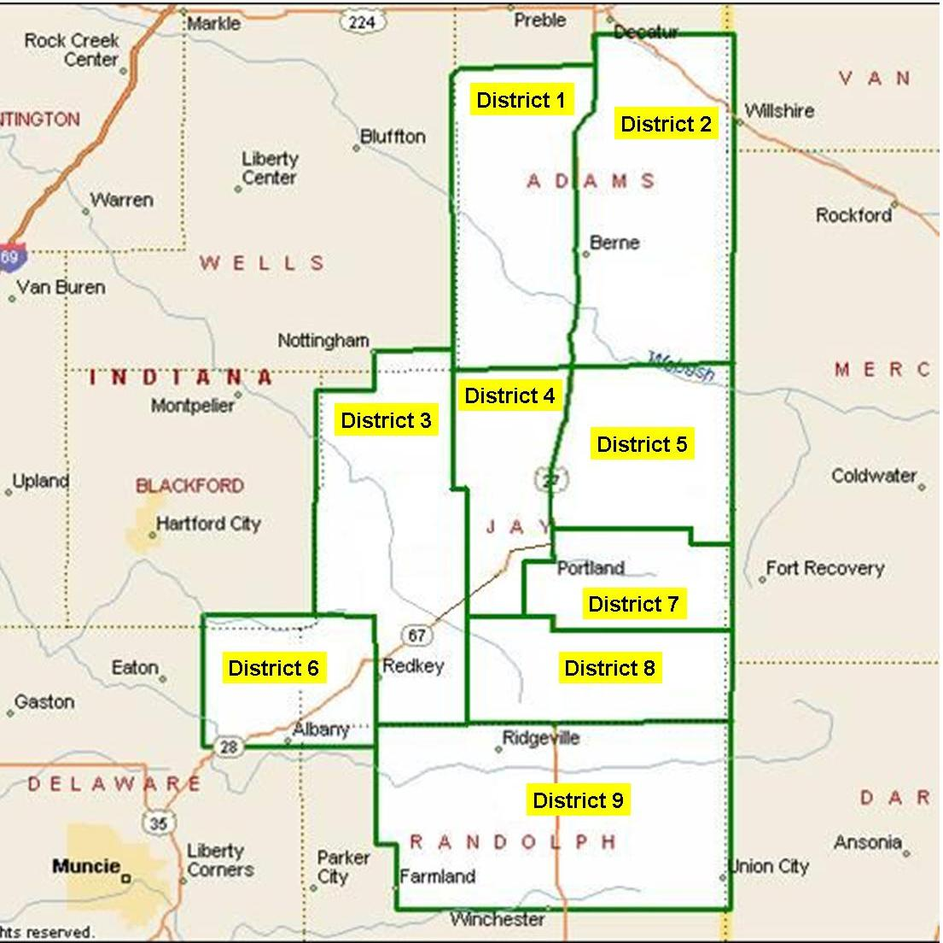

Section 3. Qualifications
Members of the board shall be members of the cooperative. The members seeking election from a district shall reside in that district.
No one may become or remain a member of the board of directors who is a close relative (as defined below) of another member of the board of directors or an employe of the cooperative.
Beginning with the year 2022, the directors of the cooperative shall be divided into three classes, each consisting of three members. The first class shall consist of directors from Districts 3, 6, and 7. The second class shall consist of directors from Districts 2, 5, and 9. The third class shall consist of directors from Districts 1, 4, and 8. At the annual meeting of the cooperative held in 2022, directors from the first class shall be elected by secret ballot by and from the members to serve for a period of three years or until their successors shall have been elected and shall have qualified. At the annual meeting of the cooperative held in 2023, directors from the second class shall be elected by secret ballot by and from the members to serve for a period of three years or until their successors shall have been elected and shall have qualified. At the annual meeting of the cooperative held in 2024, directors from the third class shall be elected by secret ballot by and from the members to serve for a period of three years or until their successors shall have been elected and shall have qualified. At each annual meeting thereafter directors shall be elected by secret ballot by and from the members to succeed those directors for a period of three years or until their successors shall have been elected and shall have qualified. If an election of directors shall not be held on the date designated herein for the annual meeting, or at any adjournment thereof, a special meeting of the members shall be held for the purpose of electing directors within a reasonable time thereafter. Directors shall be elected by a plurality vote of the members.
Upon establishment of the fact that a board member is holding the office in violation of any provisions of the bylaws, the Board shall remove such member from office.
Nothing contained in this section shall affect in any manner whatsoever the validity of any action taken at any meeting of the board.

Section 4. Nomination
Any fifteen (15) members of the cooperative, by signing a petition, may nominate a qualified candidate from any district of the cooperative for which there is to be elected a member of the board of directors at the next election of directors. Such petition shall be on a form provided by the cooperative and shall be filed at the principal office of the cooperative no less than sixty (60) days prior to the date such election is to be held. Except in the case of a removal of a director, this procedure shall be the only method by which candidates for the position of director of the cooperative shall be nominated.
The secretary shall be responsible for mailing with the notice of the meeting or separately, but at least ten (10) days before the date of the meeting, a statement of the number of directors to be elected and the names and addresses of the candidates and showing the terms of office for which each candidate would be elected. The names of the candidates shall be arranged by nominating districts with the incumbents, if nominated, listed first, followed by the other candidates alphabetically.

Section 5. Election Committee
The board shall annually elect an election committee from within its membership consisting of three (3) directors whose terms do not expire during their term of membership on this committee. It shall be the committee’s responsibility to review and validate petitions of nominations or qualifications of candidates for the office of director of the cooperative. The cooperative counsel shall be available to provide advice to the committee.

Section 6. Election of Directors
Election of directors shall be by printed ballot, except as modified hereinafter. The ballots shall list names of candidates nominated and such names shall be arranged by nominating districts with the incumbents, if nominated, listed first, followed by other candidates alphabetically.
Each member of the cooperative present in person at the meeting shall be entitled to vote for one candidate from each district from which a director is to be elected. The candidate from each district from which a director is to be elected receiving the highest number of votes at such meeting shall be declared elected as director. Drawing by lot shall resolve, where necessary, any tie votes. In the event that only one (1) candidate is nominated from a district for which a director is to be elected, then and in such event, such director may be elected by a voice vote of the membership.

Section 7. Vacancies
Subject to the provisions of these bylaws with respect to the removal of directors, vacancies occurring on the board of directors shall be filled by a majority vote of the remaining directors and directors thus elected shall serve for the unexpired portion of the term in which the vacancy has occurred or until a successor shall have been qualified, provided the director elected to fill the vacancy shall meet all qualifications of a director.

Section 8. Compensation
Directors who have been elected prior to January 1, 2025 may receive insurance benefits, if eligible in accordance with board policy and insurance provisions, and a fixed sum for each day or portion thereof spent on cooperative business, such as attendance at meetings, conferences and trade programs or performing other director duties when such has had prior approval of the board. Directors elected after January 1, 2025 are not eligible for insurance benefits but will receive a fixed sum for each day or portion thereof spent on cooperative business. When a director is replaced by member vote, the successor becomes the acting director immediately following the announcement of said member vote. The successor will attend all future director meetings and will begin receiving the fixed sum per diem. If the former director was receiving insurance benefits, the former director will maintain insurance benefits through the end of the month of the member vote. If authorized by the board, board members may also be reimbursed for expenses actually and necessarily incurred in carrying out such cooperative business or granted a reasonable per diem allowance by the board in lieu of detailed accounting for such expenses. No board member shall receive compensation for serving the cooperative in any other capacity, however, a director who is also an officer of the board, and who as such officer performs regular or periodic duties of a substantial nature for the cooperative in its fiscal or corporate affairs, may be compensated in such an amount as shall be fixed and authorized in advance of such service by the board. No close relative of a board member shall receive compensation for serving the cooperative, unless the payment and amount of compensation shall be specifically authorized by a vote of the members or the service by the board member or his close relative shall have been certified by the board as an emergency measure.

Section 9. Removal of Directors or Officers by Members
A director may be removed for cause at any time by the members pursuant to the procedures specified in this section. Any member may bring charges, specifying the causes for removal, against a director by filing such charges in writing with the secretary, together with the petitions signed by 25% percent of the members of the cooperative requesting the removal of the director in question. The petition shall contain the specific charges of misconduct. The removal shall be voted upon at the next regular or special meeting of members. The affirmative vote of 25% of the members of the cooperative is required to affect such removal. Any vacancy created by such removal may be filled by the members at such meeting provided that the director resides in the same district as the director in respect to whom the vacancy occurs.
The director against whom such charges have been brought shall be informed in writing of the charges at least thirty (30) days prior to the meeting. That director shall have an opportunity at the meeting to be heard in person or by counsel and to present evidence; and the person or persons bringing the charges against him will have the same opportunity. If the removal of more than one director is sought, a separate vote shall be taken as to each director. The term “for cause” as used in this section is defined as malfeasance in office; that is, the commission of an act which is unlawful and which affects, interrupts or interferes with the performance of official duties.

Section 10. Close Relative Defined
[As used in these bylaws, “close relative” means a person who is related to the principal person as a spouse, child, grandchild, great grandchild, parent, grandparent, great grandparent, brother, sister, aunt, uncle, nephew, niece, or first cousin, by blood or in law.]

OR

[As used in these bylaws, “close relative” means a person who is related to the principal person: (a) by blood or in law as a spouse, child, grandchild, great-grandchild, parent, grandparent, great-grandparent, brother, sister, aunt or uncle; or (b) by blood as a nephew, niece or first cousin.]

Policies:
JAY COUNTY RURAL ELECTRIC MEMBERSHIP CORPORATION
Portland, Indiana

Policy Bulletin No. 1-9

SUBJECT: QUALIFICATIONS FOR ELIGIBILITY TO SERVE ON THE BOARD OF
DIRECTORS

I. PURPOSE

The purpose of this policy is to publish the qualifications for election or appointment to, and service on, the Cooperative’s Board of Directors and to establish necessary procedures, including an affirmation form.

II. POLICY

Certain qualifications are required by law and the Cooperative’s Bylaws to become and remain a Director of the Cooperative. It is the responsibility of the Board of Directors to ensure that those qualifications are met. If the Board of Directors should determine that an incumbent Director, nominee, or potential appointee to the Board of Directors lacks or has lost any of the necessary qualifications, it is the duty of the Board of Directors to remove such incumbent or to declare such nominee or potential appointee ineligible for election or appointment.

III. PROVISIONS

A. General Requirements

Any person, to become and remain a Director of the Cooperative, shall, among other things:

1. Comply with applicable requirements of law, the Cooperative’s Articles of Incorporation and Bylaws, the Cooperative’s duly adopted policies, and the Cooperative’s duly made decisions;

2. Assume a fiduciary duty to act, in good faith, in the best interests of the Cooperative and its members;

3. Not have conflicting commercial or personal interests;

4. Be willing to devote such time and effort to the duties of a Director as may be necessary to manage the Cooperative’s affairs; and

5. Be willing and able to attend regularly scheduled and special meetings of the Board of Directors; national, state, and other meetings of organizations with associated interests that further the Cooperative movement; training institutes or seminars which will aid in keeping him well informed on matters affecting the Cooperative.

B. Service as a Director includes the following responsibilities:

1. To put forth effort to understand the Cooperative’s problems and to provide the judgment needed to reach decisions in constantly changing circumstances.

2. To support all official decisions and actions made or taken by a majority of the Board.

3. To study the information contained in reports submitted to the Board.

4. To contribute to the development of statements on functions and responsibilities of Board members and to work toward their constant improvement.

5. To evaluate and consider the questions and problems with which the Cooperative is faced.

6. To keep informed as to the ideals and objectives of the Cooperative and to further study and analyze the policies, plans, and problems which result from efforts to achieve such ideals and objectives.

7. To keep informed on, alert to, and aware of the attitudes of the members, the employees, and general public toward the Cooperative’s objectives and policies.

C. Upon the establishment of the fact that a Director is holding office in violation of Board Policies, it shall immediately become incumbent upon the Board of Directors to remove such Director from office. Such removal shall be accomplished upon a majority vote of the Directors which are not in dispute.

D. Procedure for Policy Implementation

This policy shall be implemented as follows:

1. Immediately after receipt of any nomination by petition, the Cooperative shall furnish the nominee with a copy of this policy, an Affirmation Form, and a questionnaire, to ensure that the nominee is qualified in accordance with this policy.

2. The Board of Directors, in filling any vacancies occurring on the Board of Directors, shall ensure that a proposed Director is qualified to be appointed and is apprised of this policy before appointment.

3. All persons nominated or being considered for appointment as Directors shall, prior to election or appointment, read this policy and execute the Affirmation Form and questionnaire which are attached hereto and made a part hereof.

IV. RESPONSIBILITY

The Board of Directors is responsible for the enforcement of this policy.

All previous policies pertaining to the above subject shall be rescinded as of the date of this policy.

APPROVED BY THE BOARD OF DIRECTORS

CHAIRMAN SECRETARY

ADOPTED: 11/12/19 EFFECTIVE: 11/12/19

Jay County REMC
QUESTIONS CONCERNING QUALIFICATIONS FOR DIRECTORS
Introduction
Certain specific qualifications to be eligible to become and remain a Director are set forth in the Cooperative Bylaws. In addition, statutory and common law impose certain duties upon Directors. The following questions are designed to ensure that you are eligible to be a candidate for Director and to remain a Director if elected.

1. Full Name:

2. Address of Primary Residence:

3. Are you a member of the Cooperative?
Yes No
4. Do you receive electric service from the Cooperative at the above residence?
Yes No
5. A Director is responsible for, and must actively participate in, the management of the business and affairs of the Cooperative. The Board of Directors of the Cooperative is quite active with regular and special meetings of the Board, General Membership, committees, educational opportunities and other activities.
Are you able to commit that amount of time to be actively involved in the affairs of the Cooperative?
Yes No
6. Are you employed by, or financially interested in a company which competes with the Cooperative, sells energy or supplies to the Cooperative, or its primary business is selling electrical or plumbing appliances, fixtures, or supplies to the members of the Cooperative?
Yes No

If yes, please explain.

Jay County REMC
AFFIRMATION OF DIRECTOR QUALIFICATION

I, the undersigned, hereby state and affirm as follows:

1. I have read the Cooperative's corporate policy entitled "Qualifications for Eligibility to Serve on the Cooperative's Board of Directors" and all attachments thereto.

2. I am willing to serve as such Director, if elected by the membership.

day of , 20 .

Signature

